Antonio N.J

Sept 13, 2017

1.Motherboard

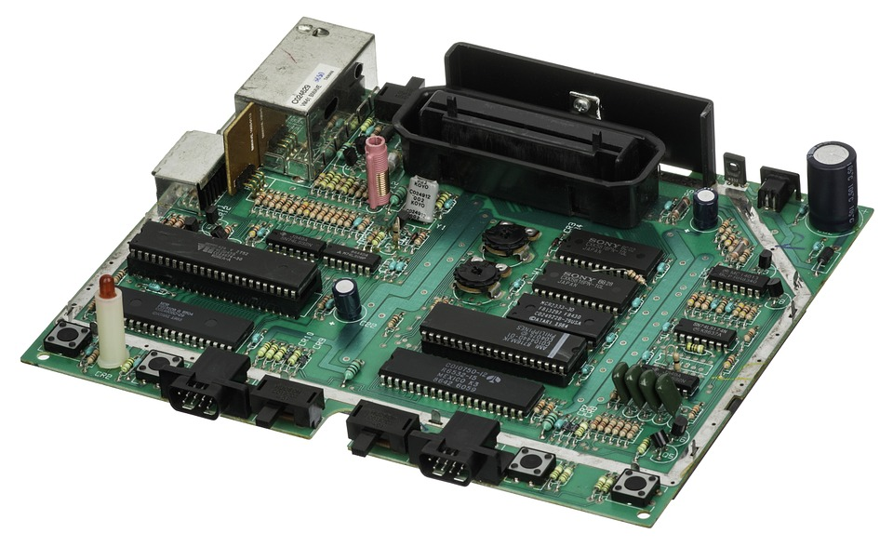

The motherboard is the computer's maincircuitboard. It's a thin plate that holds the CPU, memory, connectors for the hard drive

2.Cpu/Processor

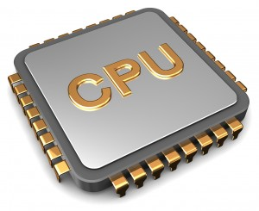

The central processing unit (CPU), also called a processor, is located inside the computercase on the motherboard. It is sometimes called the brain of the computer, and its job is to carry out commands.

#### 3.Ram(random access memory)

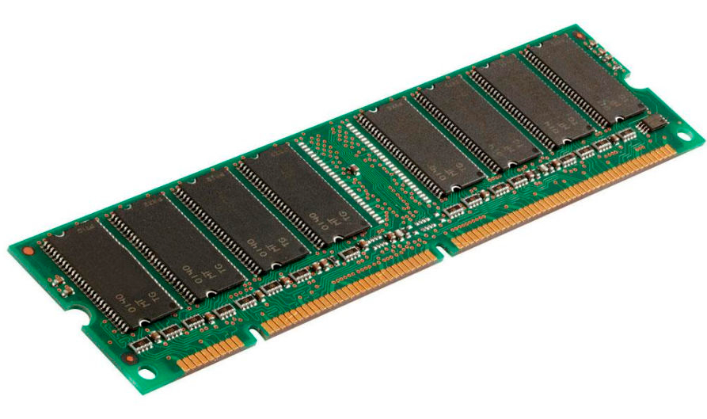

RAM is your system's short-termmemory. Whenever your computer performs calculations, it temporarily stores the data in the RAM until it is needed.

This short-termmemorydisappears when the computer is turned off. If you're working on a document, spreadsheet, or other type of file, you'll need to save it to avoid losing it.

4.Hard Drive

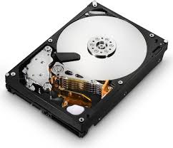

The harddrive is where your software, documents, and other files are stored. The hard drive is long**-**termstorage, which means the data is still saved even if you turn the computer off or unplug it.

5. power supply unit

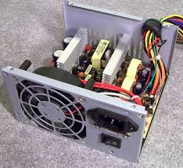

The power supply unit in a computer convertsthepower from the wall outlet to the type of power needed by the computer. It sends power through cables to the motherboard and other components.

2. Labeling the Motherboard.

* 1. Show the location of the CPU and CPU Fan.
  2. Show the location of the Memory Slots and RAM Memory
  3. Show the location of the on-board video, sound, Ethernet/Wireless and USB devices
  4. Show the location of the expansion slots and Video and Sound boards.

